Côte d'Ivoire |  |  |  |  |  |  | 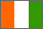
Cameroon |  |  |  |  |  |  | 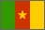
Belgium |  |  |  |  |  | 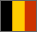
Bulgaria |  |  |  |  |  |  | 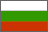
Benin |  |  |  |  |  |  | 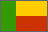
Afghanistan | 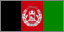
Argentina | 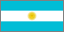
Austria |  |  |  |  |  |  | 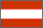
Australia |  |  | 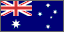
England |  |  |  | 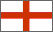
France |  |  |  |  |  |  | 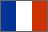
Grenada |  |  |  |  |  | 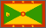
Georgia |  |  |  |  |  |  |  | 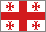
Germany |  |  |  |  |  | 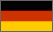
Haiti |  |  |  |  |  |  | 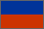
Italy |  |  |  |  |  |  | 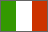
Ireland |  | 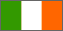
India |  |  |  |  |  |  | 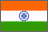
Indonesia |  |  |  |  | 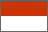
Jamaica |  | 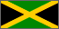
Mauritius |  |  |  |  |  |  | 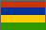
Malta |  |  |  |  |  |  | 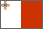
Madagascar |  |  |  |  |  |  | 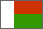
Monaco | 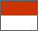
Nauru |  |  | 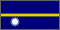
Panamá |  |  | 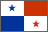
Scotland |  |  | 
Uganda |  |  | 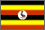
Maldives |  |  | 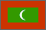
Finland |  |  | 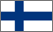
Greenland |  |  | 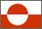
Bahrain |  |  | 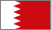
Togo |  |  | 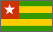
Tonga |  |  | 
Portugal |  |  | 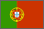
Pakistan |  |  | 
Sri Lanka |  |  | 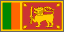
Samoa |  |  | 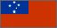
East Timor |  |  | 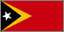
Christmas Island |  |  | 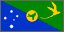
Dominican Republic |  |  | 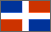
Northern Ireland |  |  | 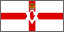
Papua New Guinea |  |  | 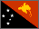
China |  |  | 